Assignment – 04
Alter Commands
-- Create 'customers' table
CREATE TABLE customers (
customer_id INT PRIMARY KEY,
first_name VARCHAR(50),
last_name VARCHAR(50),
email VARCHAR(100),
address VARCHAR(100)
);

-- Create 'employees' table
CREATE TABLE employees (
employee_id INT PRIMARY KEY,
first_name VARCHAR(50),
last_name VARCHAR(50),
age VARCHAR(10), -- This will be modified later to INT
salary DECIMAL(10, 2),
department_id INT
);

-- Create 'contacts' table
CREATE TABLE contacts (
contact_id INT PRIMARY KEY,
name VARCHAR(50),
address VARCHAR(100) -- This will be renamed later to 'home_address'
);

-- Create 'departments' table
CREATE TABLE departments (
department_id INT PRIMARY KEY,
department_name VARCHAR(50)
);

-- Create 'students' table
CREATE TABLE students (
student_id INT PRIMARY KEY,
first_name VARCHAR(50),
last_name VARCHAR(50),
email VARCHAR(100)
);

-- Create 'users' table
CREATE TABLE users (
user_id INT PRIMARY KEY,
username VARCHAR(50),
email VARCHAR(100) -- This will have a unique constraint added later
);

-- Create 'inventory' table
CREATE TABLE inventory (
product_id INT PRIMARY KEY,
product_name VARCHAR(50),
quantity INT -- Default value will be set later
);

-- Create 'products' table
CREATE TABLE products (
product_id INT PRIMARY KEY AUTO_INCREMENT,
product_name VARCHAR(50),
price DECIMAL(10, 2)
);

-- Create 'locations' table
CREATE TABLE locations (
location_id INT,
street_address VARCHAR(100),
postal_code VARCHAR(20),
city VARCHAR(50),
state_province VARCHAR(50), -- This will be renamed to 'state' later
country_id VARCHAR(2),
PRIMARY KEY (location_id)
);

-- Create 'job_history' table
CREATE TABLE job_history (
employee_id INT,
job_id VARCHAR(10),
department_id INT,
start_date DATE,
end_date DATE
);

-- Create 'jobs' table
CREATE TABLE jobs (
job_id VARCHAR(10) PRIMARY KEY,
job_title VARCHAR(50),
min_salary DECIMAL(10, 2),
max_salary DECIMAL(10, 2)
);

Querys:
1. Write a query to add a new column named 'phone_number' of type VARCHAR(20) to a table named 'customers'.
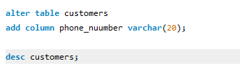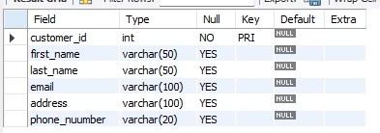
2. Write a query to modify the data type of the column 'age' in a table named 'employees' to INT.

3. Write a query to rename the column 'address' to 'home_address' in a table named 'contacts'.
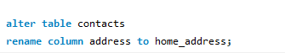
4. Write a query to add a foreign key constraint named 'fk_department' to a column named 'department_id' in a table named 'employees', referencing the 'department_id' column in a table named 'departments'.
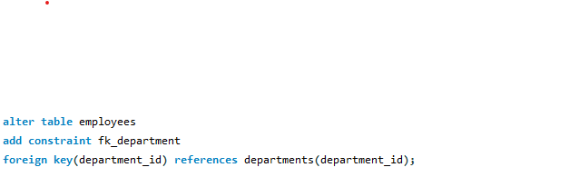
5. Write a query to drop the primary key constraint from a table named 'students'.
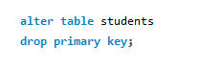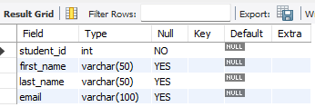
6. Write a query to add a unique constraint named 'uc_email' to a column named 'email' in a table named 'users'.
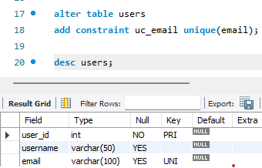
7. Write a query to add a default value of '0' to a column named 'quantity' in a table named 'inventory'.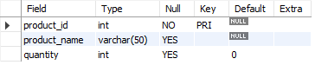

8. Write a query to modify the position of the column 'last_name' to be the first column in a table named 'customers'.
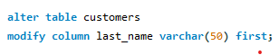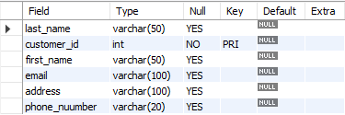
9. Write a query to change the auto-increment value of a column named 'product_id' to start from 1001 in a table named 'products'.
10. Write a query to add a check constraint named 'chk_salary' to a column named 'salary' in a table named 'employees', ensuring that the salary is greater than or equal to 2000.
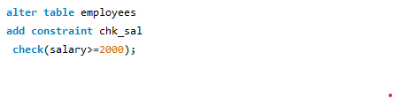

Based on hr database
1. Write a SQL statement to rename the table countries to country_new.
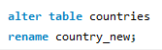
2. Write a SQL statement to add a column region_id to the table locations.
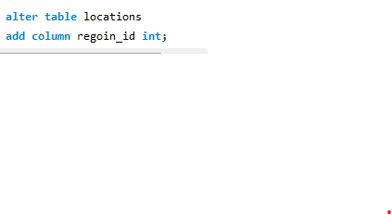
3. Write a SQL statement to add a column ID as the first column of the table locations.

4. Write a SQL statement to add a column region_id after state_province to the table locations.
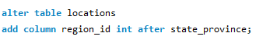
5. Write a SQL statement to change the data type of the column country_id to integer in the table locations.
alter table locations
modify column country_id int ;
6. Write a SQL statement to drop the column city from the table locations.
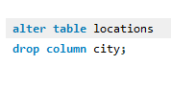
7. Write a SQL statement to change the name of the column state_province to state, keeping the data type and size
same.
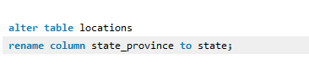
8. Write a SQL statement to add a primary key for the columns location_id in the locations table.
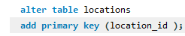
9. Write a SQL statement to add a primary key for a combination of columns location_id and country_id.
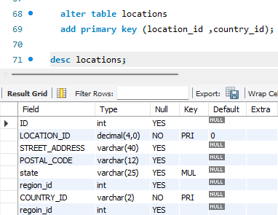
10. Write a SQL statement to drop the existing primary from the table locations on a combination of columns location_id and country_id.
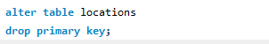
11. Write a SQL statement to add a foreign key on the job_id column of the job_history table referencing the primary key job_id of jobs table.
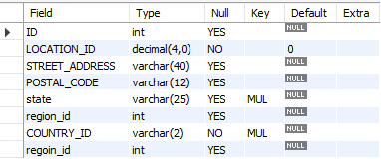
12. Write a SQL statement to add a foreign key constraint named fk_job_id on the job_id column of the job_history table referencing the primary key job_id of the jobs table.
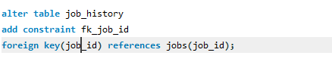
13. Write a SQL statement to drop the existing foreign key fk_job_id from the job_history table on job_id column which is referencing the job_id of jobs table.
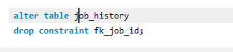
14. Write a SQL statement to add an index named indx_job_id on job_id column in the table job_history.
15. Write a SQL statement to drop the index indx_job_id from job_history table.

16. Write a query to change the length of the email column in the customers table to VARCHAR(150).
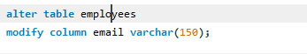
17. Write a query to add a new column status of type VARCHAR(10) with a default value of 'active' to the employees table.
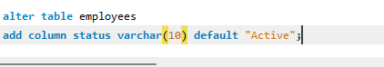
18. Write a query to drop the phone_number column from the customers table.
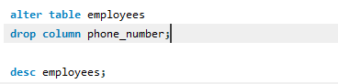
19. Write a query to modify the department_name column in the departments table to ensure it cannot contain NULL values.
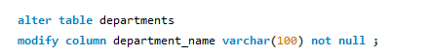
20. Write a query to drop the UNIQUE constraint on the email column in the users table.

21. Write a query to rename the inventory table to product_inventory.
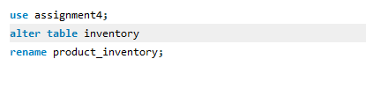
22.Write a query to add a foreign key constraint on the employee_id column of the job_history table, referencing the employee_id column of the employees table, with ON DELETE CASCADE.
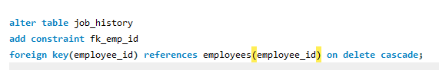
23.Write a query to change the default value of the status column in the employees table to 'inactive'.
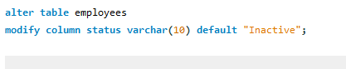
24.Write a query to drop the foreign key constraint named fk_department from the employees table.
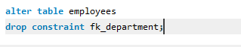
25.Write a query to move the salary column to be after the last_name column in the employees table.
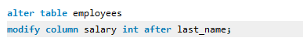
26.Write a query to remove the default value from the status column in the employees table.
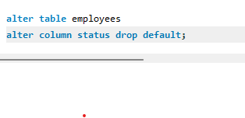
27. Write a query to rename the uc_email constraint on the email column in the users table to unique_email_constraint.

28.Write a query to disable the foreign key constraint fk_department on the employees table and then re-enable it.

29.Write a query to change the age column in the employees table to SMALLINT and allow it to accept NULL values.


